**Phone Life Cycle**

Rationale, Plan, Execution

**Rationale/Research:**

Average lifespan (replacement cycle length) of smartphones in the United States from 2014 to 2024*(in years)*

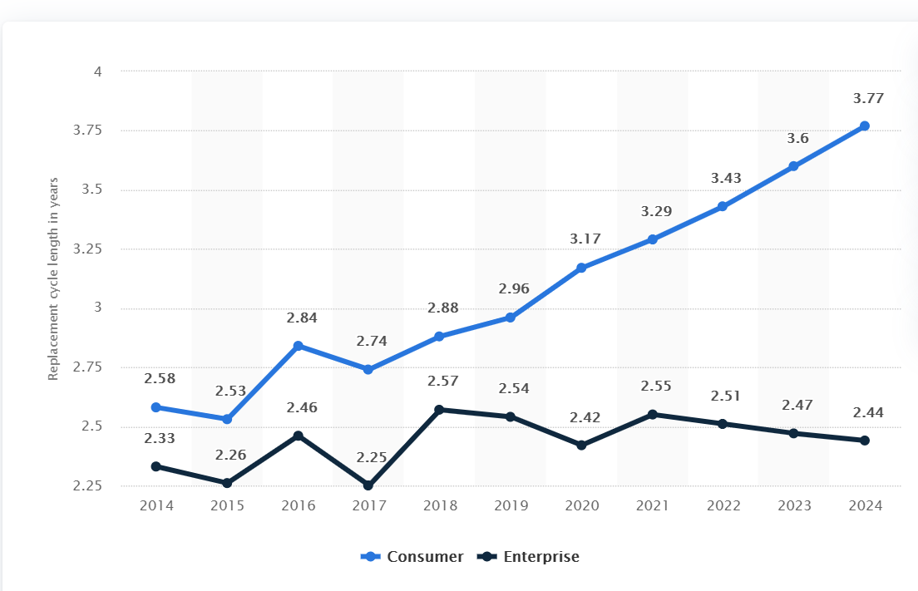

Other indicators suggest the lifecycle will come down from the current of around 40mo down to 33mo, still under enterprise replacement.

<https://www.statista.com/statistics/619788/average-smartphone-life/>

**Key Points:**

* The average phone lifespan has been on the rise, but enterprise solutions are often replaced much sooner
* The previous business landscape of cellphone carriers furthered this point by providing up-front cost discounts for contract renewal every two years.
* Flagship phone cost has gone up in recent years however, the average phone cost remains relatively stagnant.
  + Phone performance has increased however, while prices remain similar
  + This again helps account for the increase time people keep their devices.

**Takeaway:**

Based on the research we see consumers indicating that for their basic needs phones last long then they need to. We do not see this indicated in the enterprise side. This could indicate that oversight has caused enterprise replacement rates to outpace the actual need as shown by consumer demand.

I suggest a series of smaller cost options to outpace the much larger device replacement cost option. These include:

* Providing/requiring, high quality cases to ensure devices aren’t damaged unnecessarily.
* Utilize proper setup on devices to ensure remote locate and remote wipe are properly configured. This will reduce the number of lost phones.
* Ensure new phones will be supported by Android or Apple in terms of OS updates for a good number of years. OS determine how long certain software remains compatible for devices as well as certain security updates. This will prevent phones from needing to be upgraded for software related reasons.
* Ensure new phones have replaceable/semi-replaceable components. For example, iPhones have readily available parts but the new foldable Samsung will take awhile to find a replacement screen.
* Utilize on site expertise (Me) to reduce instances of user error induced replacements. To reduce to downtime caused by employees struggling through technical issues. To utilize my ability to install screen protectors, clean ports, and do small repairs to extend the lifecycle of devices.

**Plan:**

The overall life cycle plan will break down into three overall components. These are Acquisition or purchasing of new equipment. Maintenance/Use or how the product will be maintained and inventoried during its working time. End of life which details how we ensure private data is removed and phones are disposed of in an environmentally friendly and economically viable way.

1. Acquisition
   1. Ensure all new devices are compatible with needs of user.
   2. Ensure devices will have replaceable components and will be supported long term.
   3. Ensure proper configuration including set up of Google/Apple accounts, auto backups, device security, and remote locate and wipe.
   4. Ensure all data from old phone is transferred and then wiped from old phone. For disposal of old phone see EOL section.
   5. Ensure new phone is protected with quality case and screen protector. (I can install scree protectors). Additionally ensure if charger port changed that user could charge device.
   6. Log new phone and user into the inventory and set up checklists. If applicable remove old phone from user’s name in inventory checklist (IMEI, phone#, user id)
2. Maintenance/Use
   1. During initial time frame with device perform frequent check-ins to ensure new device is learned and functional. Perform any training necessary for user to understand device operation.
   2. Perform monthly performance and condition checks.
      1. Check software updates
      2. Ensure backups are working and up to date
      3. Ensure no malware is present
      4. Clear cache
      5. Ensure physical condition is satisfactory. Take note of any damage or defects and add to inventory checklist. This includes noting broken screen protectors, ordering replacements, and performing the replacement.
   3. Monitor life cycle of devices and plan for anticipated replacements. Work with users to find new device when time comes.
      1. Replacements may not be necessary at the same time for all roles. Some roles require more from the phone. Additionally, some users will prefer to keep their existing setup to not learn a new device. This can be mitigated with training; however, it is fiscally responsible to allow the user to use the device as long as possible. This is so long as the device continues to receive security updates and performs as expected.
3. End of Life

This area is of particular importance. E-waste is a growing ecological concern and improper disposal risks doing damage to planet. Outlined below are several ways to address this concern while also ensuring that no user data remains on any device once it leaves agency possession.

* 1. Buyback programs – programs run by manufacturers are usually legitimate and provide and option to easily get rid of devices.
  2. Donations – Homeless shelters, women’s shelters, even rainforest activists are looking for working phones. This allows the device to have a second life helping make the most of the materials used to assemble it. Donation sources should be researched for recycle process afterwards.
  3. On Site Backups – a certain number of phones should be kept on hand as backup devices. These are used when a phone is lost or damaged and obtaining a new one will take longer than expected. A replacement phone can be used temporarily in this situation to prevent loss of productivity.
  4. Recycle through The Basel Action Network certified e-Stewards. These are companies that pledge never to export hazardous waste to developing countries, abuse prison labor, or dump electronics in landfills.
  5. Fix/Sell – A broken phone can still be fixed. Many manufactures and third-party repair centers will replace components for less than the cost of a new device. Simple repairs can be performed by myself. However, there is a cost benefit analysis to be done as phones have a shorter life span so repairs might not make finical sense.

**Execution:**

To properly execute this strategy, it will require consistent maintenance of the inventory checklists. Additionally, the frequent condition checks of devices should be staggered as to not need to be completed all at once. Staggering also has the benefit of building rapport with staff which will encourage questions to be asked.